BigIP - SOC Collaboration

BigIP team is frequently involved in Full TAP Validation. These validations usually happen during Both IST (Secondary on-call handles usually) and US morning hours, and validations last for approximately 2~4 hours.

Stats:
Monthly – 5 tasks (avg)
Yearly – Approx 50 tasks
Hours to be saved – 80~100 hours.

Involving SOC team to do these validations would benefit both BigIP team in utilizing their IST and US morning hours on tasks and SOC engineers to learn and explore knowledge on BigIP and the products using BigIP resources.

RoadMap Accomplished:
1. Provide access to SOC before KT
2. KT on BigIP
3. Teams channel BigIP-SOC
4. Assessment
5. SOC to Shadow OE during Validations
6. Deploying SOC for validations

Trainings completed:
Session 1 & 2: BigIP Introduction, LTM, Types of Load balancing and BigIP monitors
Session 3: iApps & Templates.
Session 4: Full TAP Validation
Session 5: Real time validation with scenarios
Assessment:
Engineer |  | Task analysis |  | BigIP Dashboard check |  | BigIP IP monitoring check
SaiKrishna Manoj |  | Positive |  | Positive |  | Positive
Venkatesh Govindaswamy |  | Positive |  | Positive |  | Positive
Vigno Arockia Raj |  | Positive |  | Positive |  | Positive
Shajith Shaik |  | Positive |  | Positive |  | Positive
Mugesh |  | Positive |  | Positive |  | Positive
Fareen Sheikh |  | Positive |  | Positive |  | Positive
Tamal |  | Positive |  | Positive |  | Positive
All engineers have completed assessment and looks like we are good to onboard them for BigIP Validation. However, a couple of engineers need some brush up on basics, but they are good at handling validation.
BigIP - SOC validation task handover

- BigIP receives Validation Task
- Day prior Validation happens Validation Review meeting will be sent by BigIP team to SOC team to discuss about validation Task.
- Helix task for validation will be assigned to “Phanikiran Patakamuri” (SOC manager)
- Task which is assigned will be updated on Teams channel (CRQ Validation)
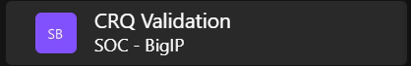

- SOC team will constantly check Teams channel and acknowledge task assigned.
- The monthly BigIP oncall schedule will be updated on Teams channel.
- Monthly SOC shift details will be updated on the Teams channel.
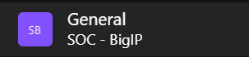

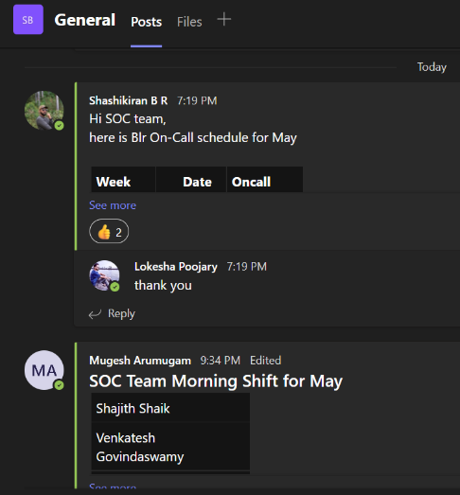

Planned to have Weekly BigIP-SOC review meeting for next few weeks to understand if there is any knowledge gap SOC team needs to be trained on.

Important URLs

Validation checklist : https://confluence.csgicorp.com/pages/viewpage.action?spaceKey=OpEngr&title=SOC%20Validation%20Checklist
Grafana Dashboard
https://dashboard.oe.csgiprod.com/d/h2EnkSpmk/bigip-home?refresh=1m&orgId=1
Username : soctechnicians
Password : Phanikiran will be sharing password

Jenkins IP monitoring jobs
Prod : https://jenkins.oe.csgiprod.com/job/BIG-IP%20IP%20Address%20Monitor%20(prod)/
Pre : https://jenkins.oe.csgiprod.com/job/BIG-IP%20IP%20Address%20Monitor%20(pre)/
Dev : https://jenkins.oe.csgidev.com/job/BIG-IP%20IP%20Address%20Monitor%20(dev)/
BigIP device list
https://confluence.csgicorp.com/pages/viewpage.action?spaceKey=OpEngr&title=Big+IP+Devices
BigIP – SOC Teams channel
https://teams.microsoft.com/l/channel/19%3akiGJzPQeieqDDgmJKO0IC_HM7Clv0duoy6WG-FGp6aA1%40thread.tacv2/General?groupId=b9616cc1-d8a7-4db2-8816-0bcab70657f3&tenantId=194a267b-82ba-4fa6-b6b9-f95966ab3815
Study reference:
CSG Degreed Pathway : https://degreed.com/pathway/jp1kojgw9v?orgsso=csgi
Udemy : https://www.udemy.com/course/learn-f5-ltm-adc/

